Exercise 2: Entity-Component System Design
1. UML Diagram of Inheritance Hierarchy
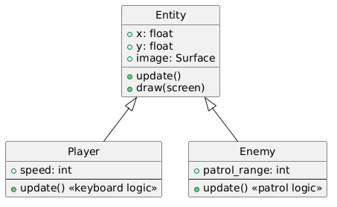
Limitations of the Inheritance Approach:
- Code Duplication: Shared logic (e.g., movement, collision) is often repeated in multiple subclasses.
- Inflexibility: Adding new behaviors (like patrolling or flying) requires modifying or creating new subclasses, making the hierarchy rigid.
- Difficult to Combine Behaviors: If an entity needs multiple behaviors (e.g., a collectible that moves), you must create new subclasses for every combination, leading to class explosion.

2. Component-Based Architecture Proposal
We redesign the system using an Entity-Component-System (ECS) approach:
- Entity: Holds a dictionary of components.
- Component: Simple data containers (e.g., Transform, Sprite, Velocity, etc.).
- System: Processes all entities with required components.
Components:
- Transform: position, rotation, scale
- Sprite: image, layer
- Velocity: dx, dy
- ControlledByPlayer: flag
- Patrol: range, speed, direction
- Collider: rect, type
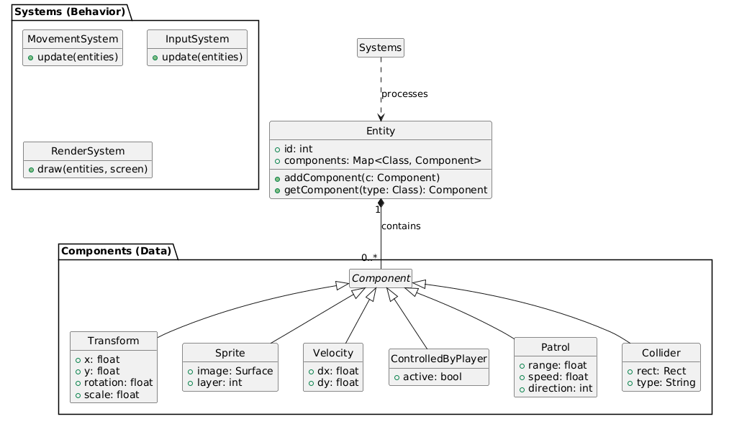

3. Core ECS Implementation in Pygame
# --- Components as simple dictionaries ---
def Transform(x, y, rotation=0, scale=1):
return {'x': x, 'y': y, 'rotation': rotation, 'scale': scale}

def Sprite(image, layer=0):
return {'image': image, 'layer': layer}

def Velocity(dx=0, dy=0):
return {'dx': dx, 'dy': dy}

def ControlledByPlayer():
return {'player_controlled': True}

def Patrol(range_, speed, direction=1):
return {'range': range_, 'speed': speed, 'direction': direction, 'start_x': None}

def Collider(rect, type_):
return {'rect': rect, 'type': type_}

# --- Entity class ---
class Entity:
def __init__(self):
self.components = {}

def add_component(self, name, component):
self.components[name] = component

def get_component(self, name):
return self.components.get(name)

# --- Systems ---
class MovementSystem:
def update(self, entities, dt):
for entity in entities:
transform = entity.get_component('Transform')
velocity = entity.get_component('Velocity')
if transform and velocity:
transform['x'] += velocity['dx'] * dt
transform['y'] += velocity['dy'] * dt

class RenderSystem:
def draw(self, entities, screen):
for entity in entities:
transform = entity.get_component('Transform')
sprite = entity.get_component('Sprite')
if transform and sprite:
x, y = int(transform['x']), int(transform['y'])
screen.blit(sprite['image'], (x, y))

4. Example: Creating a Player and Patrolling Enemy
# Assume 'player_img' and 'enemy_img' are loaded pygame.Surface objects

# --- Create player entity ---
player = Entity()
player.add_component('Transform', Transform(100, 300))
player.add_component('Sprite', Sprite(player_img))
player.add_component('Velocity', Velocity())
player.add_component('ControlledByPlayer', ControlledByPlayer())
player.add_component('Collider', Collider(pygame.Rect(100, 300, 32, 32), 'player'))

# --- Create patrolling enemy entity ---
enemy = Entity()
enemy.add_component('Transform', Transform(400, 300))
enemy.add_component('Sprite', Sprite(enemy_img))
enemy.add_component('Velocity', Velocity(50, 0)) # Moves horizontally
enemy.add_component('Patrol', Patrol(range_=100, speed=50))
enemy.add_component('Collider', Collider(pygame.Rect(400, 300, 32, 32), 'enemy'))

5. Explanation: Extending with New Behaviors
With this ECS design, adding new behaviors is easy:
- To add a new feature (e.g., jumping, AI), create a new component and a system that processes entities with that component.
- No need to modify existing entity or system classes—just add or remove components as needed.
- Behaviors are composable: an entity can have any combination of components.

